|  |  |  |  |
| --- | --- | --- | --- |
| |  |  |  | | --- | --- | --- | | Seal | Biography | Flag | |
| ***U N I T E D   S T A T E S   A I R   F O R C E*** |

## **CAPTAIN BENNETT R. JOHNSON**

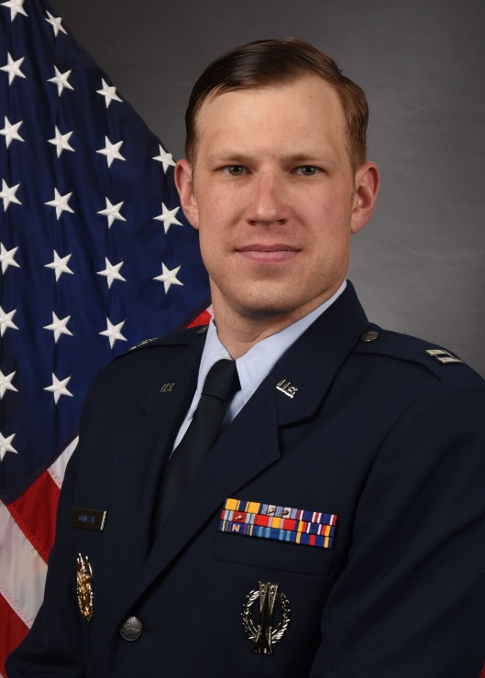Captain Bennett Johson is the Chief of Current ICBM Plans and Operations, 625Strategic Operations Squadron, Offutt Air Force Base, Nebraska. He is responsible for creating targeting materials required for ensuring readiness to execute the nuclear war plan. In addition, Captain Johnson manages and directs targeting activities for the nation's 3 missile wings, 450 ICBMs, and 45 launch Control Centers.

Captain Johnson entered the Air Force in May of 2010 through the Reserve Officer Training Corp out of Norwich University in Northfield, Vermont. He has held various positons including Missile Combat Crew Commander Instructor, and Flight Commander. Before assuming his current position, Captain Johnson was the Wing Inspection Team Manager for the 90th Missile Wing, F. E. Warren AFB Wyoming where he oversaw 180 evaluators and QA members

## EDUCATION:

2010 Bachelor of Arts, Studies of War and Peace, Norwich University Vermont

2010 Air and Space Basic Course, Maxwell AFB, Alabama

2011 ICBM Initial Skills Training, Vandenberg AFB, California

2013 ICBM Center of Excellence, F. E. Warren AFB, Wyoming

2015 Squadron Officer School, Maxwell AFB, Alabama

## ASSIGNMENTS:

1. December 2010 – September 2011, Student, ICBM Initial Skills Training, 532 TRS, Vandenberg AFB, California
2. September 2011 – October 2012, ICBM Deputy Combat Crew Commander, 321 MS, Francis E. Warren AFB, Wyoming
3. November 2012 – July 2013, ICBM Deptuy Combat Crew Instructor, 90 OSS, Francis E. Warren AFB, Wyoming
4. August 2013 – June 2014, Combat Crew Commander, 12 MS, Francis E. Warren AFB, Wyoming
5. July 2014 – October 2014, ICBM Combat Crew Instructor, 90 OSS, Francis E. Warren AFB, Wyoming
6. November 2014 – May 2015, ICBM Combat Crew Squadron Instructor, 321 MS, Francis E. Warren AFB, Wyoming
7. June 2015 – January 2016, Flight Commander, 321 MS, Francis E. Warren AFB, Wyoming
8. February 2016 – August 2017, Wing Inspection Team Manager, Inspector Generals Office, 90 MW Staff, Francis E. Warren AFB, Wyoming
9. September 2017 – Present, Chief of Current ICBM Plans and Operations, 625 STOS, Offutt AFB, Nebraska

**MAJOR AWARDS AND DECORATIONS:**

Air Force Commendation Medal with one oak leaf cluster

Air Force Achievement Medal with three oak leaf clusters

**EFFECTIVE DATE OF PROMOTION:**

Second Lieutenant May 15, 2010

First Lieutenant July 29, 2012

Captain July 29, 2014

(Current as of Sep 18)